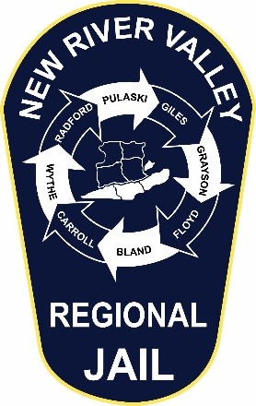New River Valley Regional Jail

P.O. Box 1067

Dublin, Virginia 24084

(540) 643-2000 (540) 643-2010 FAX

***Kimberly D. Haug***

Superintendent

**Addendum # 2**

**The following information has been added to the Contract Terms, Attachment D. This supersedes all questions that may have arisen from page 15. Please complete in its entirety**

**(FOR OFFEROR INFORMATIONAL PURPOSES)**

13.EXTENT OF AGREEMENT/MODIFICATION

This Agreement, together with all Attachments and addenda, represents the entire and integrated Agreement between the parties hereto and supersedes all prior negotiations, representations, or agreements, either written or oral. This Agreement may be amended, modified or added to only by written instrument properly signed by both parties hereto.

Signature:_____________________________ Date:____________________

Title: