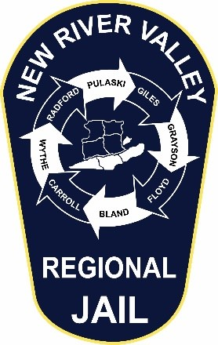
New River Valley Regional Jail
P.O. Box 1067
Dublin, Virginia 24084
(540) 643-2000 (540) 643-2010 FAX

Kimberly D. Haug
Superintendent

For RFP-24-002 the mandatory pre-bid will be held via zoom on June 13th, 2024 from 10:30 am to 1:30 pm. Please reach out to Jared Hovencamp via email (jwhovencamp@nrvrj.org) or at 540-643-2025 to schedule and obtain the link for the zoom meeting.

